Exam Questions – With Solutions

Briefly describe the behaviour of the y values for the following, given the behaviour of the x values: y = $\frac{1}{x}$ , as x → –∞
y → 0

A parabola with equation $y=a(x-b)(x+c)$ has turning point (2, –8) and y-intercept (0, –6). The constants a, b and c are all positive.
[a] Determine the values of the positive constants a, b and c.
y = a(x–2)² – 8
–6 = a(–2)² –8 a = 0.5
y = 0.5(x–2)² – 8 = 0.5(x+2)(x–6)
a = 0.5, b = 6, c = 2

[b] The parabola is translated 10 units left and 5 units downwards. Determine the equation of the transformed parabola in the form $y=a(x-p)^{2}+q$.
y = 0.5(x+10–2)² – 8 – 5
y = 0.5(x+8)² –13

An obtuse-angled triangle ABC has a = 36cm, c = 52cm and an area of 748cm².
[a] Sketch a triangle to show this information.
B
52cm
36cm
A
C
748cm²
[b] Determine the size of ∠B.
748 = $\frac{1}{2}$ x 52 x 36 x sin(∠B)
∠B = 53.05° But it’s obtuse so ∠B = 180 – 53.05 = 126.95°

[c] Show that b ≈ 79cm.
b = $\sqrt{{52}^{2}+ {36}^{2}-2 x 52 x 36 x cos⁡(126.95)}$= 79.06 ≈ 79

[d] Show that ∠C ≈ 32°.
$$\frac{sin(∠C)}{52}= \frac{sin⁡(126.95)}{79}$$
sin(∠C) = 0.526 ∠C = 31.74° ≈ 32°

A small weight, attached to the bottom of a spring, oscillated up and down. The distance, d cm, of the weight from the top of the spring after t seconds can be modelled by:
$$d=45+35\sin{(\frac{3πt}{4}})$$
[a] Sketch the graph on the axes below for 0 ≤ x ≤ 3.
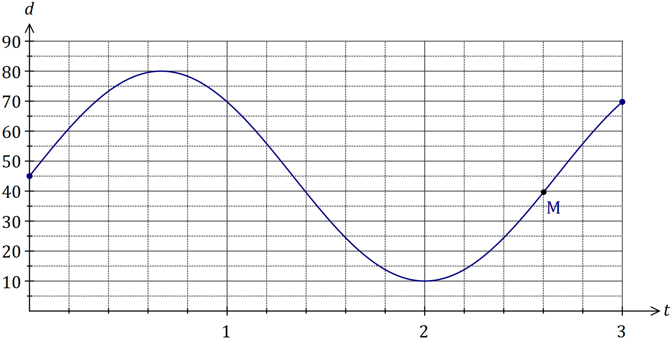
[b] Mark on your graph point M, where the weight is 40cm from the top of the spring and moving downwards.
Hint: As d gets larger, the spring is moving downwards, so M is as d gets larger.

[c] Determine
(i) The maximum distance of the weight from the top of the spring.
Maximum distance = maximum value for d = 80cm

(ii) The time taken for the spring to return to its initial position.
b = $\frac{3π}{4}$
Period = $\frac{2π}{b}$ = $\frac{2π}{\frac{3π}{4}}$ = 2π x $\frac{4}{3π}$ = $\frac{8}{3}$
Time to return to initial position is half the period so t =0.5 x $\frac{8}{3}$ = $\frac{4}{3}$ = 1.35 seconds

(iii) The distance moved by the weight between t = 1 and t = 2.
d(1) – d(2) = 69.75 – 10 = 59.75cm

In shape OABCD below, ∠AOB = 126° and AC, BD are diameters of the circle with centre O and radius 35cm.
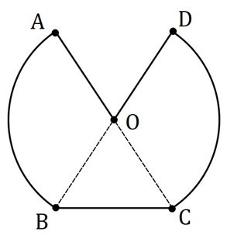

[a] Calculate the perimeter of OABCD.
AB + DC = 2 x 35 x $\frac{126π}{180}$ = 153.94cm
BC = $\sqrt{{35}^{2}+{35}^{2}-2 x {35}^{2} x cos⁡(\frac{360-2 x 126}{2})}$
= 31.78cm
AO + DO = 35 x 2 = 70cm
Perimeter = 153.94 + 31.78 + 70 = 255.72cm

[b] Calculate the area of OABCD.
AOB + DOC = 2 x $\frac{1}{2}$ x 35² x $\frac{126π}{180}$ = 2693.94cm²
BOC = $\frac{1}{2}$ x 35² x sin($\frac{360-2 x 126}{2}$) = 495.52cm²
Area = 2693.94 + 495.52 = 3189.cm²

Let a = sin50 and b = cos100.
Give your answers to the following in terms of a and/or b.
[a] Write an expression for
(i) sin130
sin130 = sin50 = a

(ii) cos80
cos80 = – cos100 = –b

[b] Determine an expression for cos130.
cos²130 + sin²130 = 1
cos²130 = 1 – a²
cos130 = $±\sqrt{1-a^{2}}$
But cos130 is negative cos130 = $-\sqrt{1-a^{2}}$

[c] Determine an expression for tan130.
tan130 = $\frac{sin130}{cos130}$ = $\frac{a}{\sqrt{1-a^{2}}}$

The graph of y = f(x) is shown below, where f(x) = is shown below, where f(x) = sin(x+c) and c is a constant.
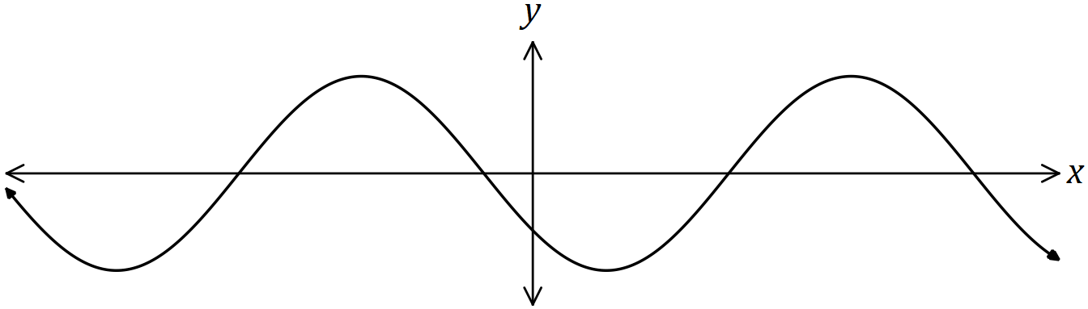
Explain how to obtain the graph of each function below from the graph of f(x), given that a and b are also constants.
[a] y = sin(x+a).
sin(x+c) sin(x+a) Subtract c and add a.
sin(x+c–c+a) = sin(x+a)
sin(x+c–(x–a) = sin(x+a)
Translate horizontally by (c–a) units.

[b] y = cos(x+b).
sin(x+c) cos(x+b)
sin(x+c) = cos(x+c$-\frac{π}{2}$) Subtract c and add b.
cos(x+c+$\frac{π}{2}$ – c+b) = cos(x+b)
cos(x+c–($-\frac{π}{2}$+c–b) = cos(x+b)
Translate horizontally by (c–b$-\frac{π}{2}$) units.

The circle shown has centre O and diameter AC of length 50cm. Determine the shaded area given that 2 x ∠AOB = 3 x ∠BOC.
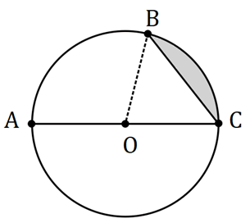
∠AOB + ∠BOC = 180°
∠BOC = $\frac{2}{3}$ x ∠AOB
CAS simultaneous ∠BOC = 72°, ∠AOB = 108°
Area = $\frac{1}{2}$ x 25² x $\frac{72π}{180}$ – $\frac{1}{2}$ x 25² x sin($\frac{72π}{180}$) = 95.49cm²

A sector of a circle has a perimeter of 112cm and an area of 735cm². Determine the radius of the circle.
$\frac{1}{2}$ x r² x θ = 735
r x θ + 2r = 112
CAS simultaneous r = 21cm, 35cm

Line L has equation $\frac{x}{4}+ \frac{y}{5}=1$.
[a] Determine the equation of line P that’s perpendicular to L and passes through the point with coordinates (50, 4).
Line L: y = $-\frac{5}{4}$ x + 5
Line P: y = $\frac{4}{5}$ x + c
Substitute (50, 4) 4 = 40 + c c = –36

[b] Determine the coordinates of the point of intersection of L and P.
Line P: y = $\frac{4}{5}$ x – 36
Line P = Line L $\frac{4}{5}$ x – 36 = $-\frac{5}{4}$ x + 5
$\frac{41}{20}$ x = 41 x = 20
When x = 20, y = –20 (20, –20)

A running track has circular ends of radius 100m and two straight, parallel sides $PQ$ and $RS$ that are both 120m long, as shown below. Determine, to the nearest metre, the total length of the track.
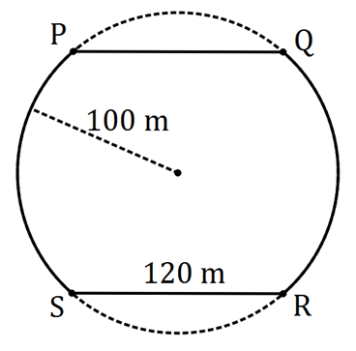
120² = 100² + 100² – 2 x 100² x cos(x) x = 1.287 radians
$\frac{2π-2 x 1.287}{2}$ = 1.855 radians
PS + QR = 2 x 100 x 1.855 = 370.92m
Perimeter = 120 x 2 + 370.92 = 610.92m ≈ 611m

The diagram shows a circle with centre $O$ and diameter $BC$, and an equilateral triangle ABC. Determine the exact fraction of the area of the circle that lies outside the triangle.
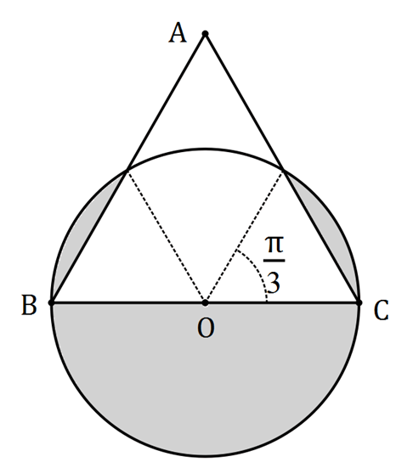
Area outside = $\frac{1}{2}$ x π x r² + 2 x ( $\frac{1}{2}$ x r² x $\frac{π}{3}$ – $\frac{1}{2}$ x r² x sin $\frac{π}{3}$) = $\frac{πr^{2}}{2}$ + $\frac{r^{2}π}{3}$ – $\frac{r^{2}\sqrt{3}}{2}$
= $\frac{3πr^{2} + 2r^{2}π - 3\sqrt{3}r^{2}}{6}$
Fraction = $\frac{Outside area}{Circle area}$ = $\frac{3πr^{2} + 2r^{2}π - 3\sqrt{3}r^{2}}{6}$ x $\frac{1}{πr^{2}}$ = $\frac{r^{2}(3π + 2π - 3\sqrt{3})}{6}$ x $\frac{1}{πr^{2}}$ = $\frac{3π + 2π - 3\sqrt{3}}{6π}$
= $\frac{5π-3\sqrt{3}}{6π}$

Line A and Line B in the x-y plane intersect at 90° at the origin. Line A has a slope of $\frac{1}{3}$. Point (2, –6) is the midpoint of line segment CD which is parallel to Line A. Given that the x-value of C is –1, find the coordinates of point D.
2 = $\frac{-1+x}{2}$ x = 5
$\frac{y_{1}+y_{2}}{2}$ = –6 y₂ + y₁ = –12
$\frac{y_{2}-y_{1}}{x_{2}-x_{1}}$ = $\frac{y_{2}-y_{1}}{5-(-1)}$ = $\frac{y_{2}-y_{1}}{6}$ = $\frac{1}{3}$ y₂ – y₁ = 2
y₂ + y₁ = –12
P(D) = (5, –5)
2y₂ = –10 y₂ = –5
y₂ – y₁ = 2
Use gradient: $\frac{y_{2}-y_{1}}{6}$ = $\frac{1}{3}$ y₂ – y₁ = 2 –5 – y₁ = 2 y₁ = –7 P(C) = (–1, 7)

Complete the square to find the roots of the quadratic function f(x) = 5x² – 7x + 1.
5x²–7x + 1 = 5(x² – $\frac{7}{5}$x + $\frac{1}{5}$)
= 5(x² – $\frac{7}{5}$x + $\frac{49}{100}$ – $\frac{49}{100}$ + $\frac{1}{5}$)
= 5(x – $\frac{7}{10}$)² – $\frac{29}{20}$
5(x – $\frac{7}{10}$)² = $\frac{29}{20}$
(x – $\frac{7}{10}$)² = $\frac{29}{20}$ x $\frac{1}{5}$ = $\frac{29}{100}$
x – $\frac{7}{10}$ = $\sqrt{\frac{29}{100}}$ = ±$\frac{\sqrt{29}}{10}$
x = $\frac{7}{10}$ ± $\frac{\sqrt{29}}{10}$ = $\frac{7±\sqrt{29} }{10}$

The current A (amperes), varies inversely to the resistance R (ohms) in an electric circuit. When the resistance is 12 ohms, the current is 0.5 amperes. Determine the effect on R if A is increased by 35%.

R = $\frac{6}{A}$
Increased by 35%: R = $\frac{6}{0.5 x 1.35}$ = 8.89
Effect = $\frac{12-8.89}{12}$ x 100 = 25.9% Therefore, R decreases by 25.9%

A sector OPQ of a circle with centre O is drawn below. The radius of the circle is 18 cm and angle POQ is 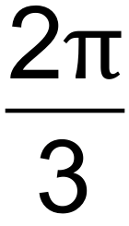 radians. The tangents to the circle at the points P and Q meet at point R. 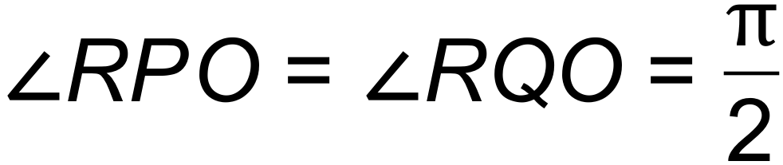. Find the exact area of the shaded region.
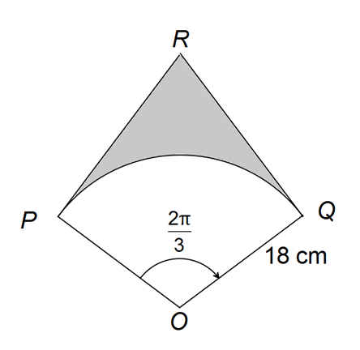
tan($\frac{π}{3}$) = $\frac{PR}{18}$ PR = 18tan($\frac{π}{3}$)
Triangle area = $\frac{1}{2}$bh = $\frac{1}{2}$ x 18 x 18tan($\frac{π}{3}$)
Kite area = 2 x $\frac{1}{2}$ x 18 x 18tan($\frac{π}{3}$) = 18 x 18tan($\frac{π}{3}$)
Sector area = $\frac{1}{2}$ x 18² x $\frac{2π}{3}$
Shaded area = (18 x 18tan($\frac{π}{3}$)) – ($\frac{1}{2}$ x 18² x $\frac{2π}{3}$) = 324$\sqrt{3}$ – 108π = 108(3$\sqrt{3}$ – π)

The circle with centre A(5, 8) touches the 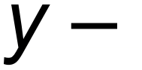axis as shown below.
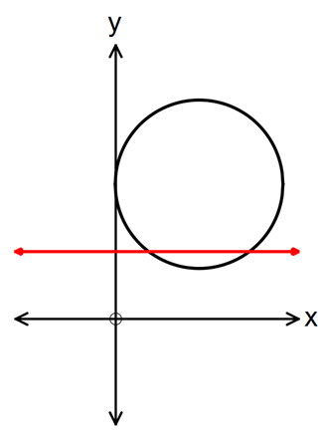
The line y = 4 intersects the circle at point M and N.
[a] Determine the length of the chord MN.

(x – 5)² + (y – 8)² = 25 substitute y = 4 x = 2, x=8 6 units
[b] Find the area of the minor segment formed between MN and the circle.

6² = 5² + 5² – 2 x 5² x cosθ θ = 1.287 radians
$\frac{1}{2}$ x 5² x 1.287 – $\frac{1}{2}$ x 5² x sin(1.287) = 4.0875 units²

The diagram below has an arc, PQ, of a circle with centre O and radius r.
PR is perpendicluar to OQ. Angle POQ = 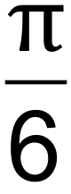 radians.
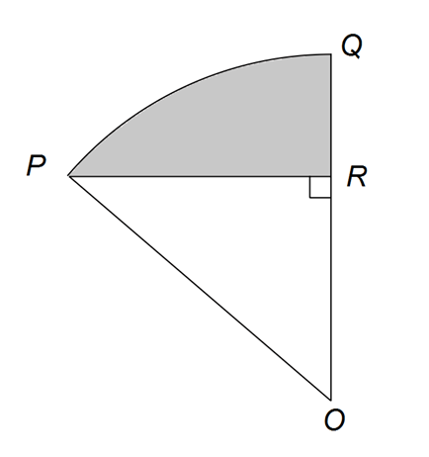
[a] Show that the area of triangle POR = $\frac{r^{2}\sqrt{3}}{2}$ in terms of r. (Hint: First find expressions for OR and RR in terms of r).

sin($\frac{π}{6}$) = $\frac{PR}{r}$ PR = $\frac{r}{2}$
cos($\frac{π}{6}$) = $\frac{OR}{r}$ OR = $\frac{r\sqrt{3}}{2}$
Triangle area = $\frac{1}{2}$ x $\frac{r\sqrt{3}}{2}$ x $\frac{r}{2}$ = $\frac{r^{2}\sqrt{3}}{8}$

[b] If the shaded area is $\frac{2π-3\sqrt{3}}{6}$ cm², calculate the value of r.

Shaded area = sector area – triangle area
$\frac{2π-3\sqrt{3}}{6}$ = $\frac{1}{2}$ x r² x $\frac{π}{6}$ – $\frac{r^{2}\sqrt{3}}{8}$
CAS r = 2, r = –2 (reject x = –2)
r = 2

The perimeter of a sector, with central angle θ radians in a circle of radius r, is 12 cm
[a] Express θ in terms of r.

12 = rθ + 2r
θ = $\frac{12-2r}{r}$ = $\frac{12}{r}$ – 2

[b] Show that the area of the sector is 6r – r².

$\frac{1}{2}$ x r² x ($\frac{12}{r}$ – 2) = $\frac{12r^{2}}{2r}$ – r² = 6r – r²

[c] Determine the area of the sector if θ = 1.

$\frac{12}{r}$ – 2 = 1
12 – 2r = r
–3r = –12
r = 4
$\frac{1}{2}$ x 4² x 1 = 8cm²
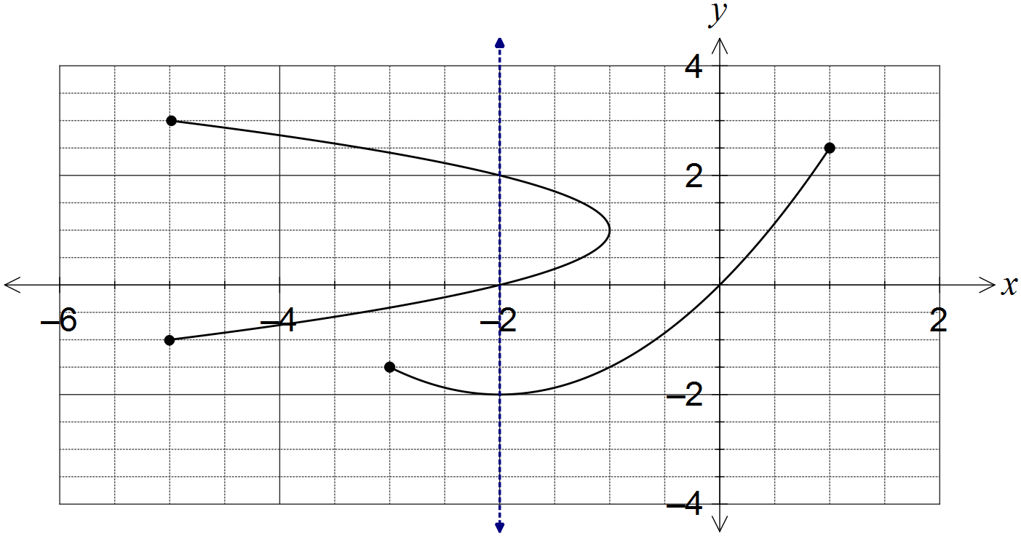
The relation can be expressed in the form y² = ax + by – 2. Determine the values of the constants a and b.

When x = 0, y = 0, 2
When y = 0 0² = –2a + b(0) – 2 a = –1
When y = 2 2² = –2(–1) + 2b – 2 b = 2

In triangle ABC, ∠BAC, AC = 18.4 cm and BC = 15 cm.
Determine the largest possible area and smallest possible perimeter of this triangle.
B
15
18.4 cm
50°
C
A

$\frac{sinB}{18.4}$ = $\frac{sin50}{15}$ ∠B = 70°, 110°
∠C = 180 – 50 – 70 = 60° or 180 – 50 – 110 = 20°
Largest area = $\frac{1}{2}$ x 18.4 x 15 x sin60 = 119.51°

AB² = 18.4² + 15² – 2 x 18.4 x 15 x cos20 cos60 < cos20
AB = 6.70
Largest perimeter = 15 +18.4 + 6.70 = 40.10cm

